1. 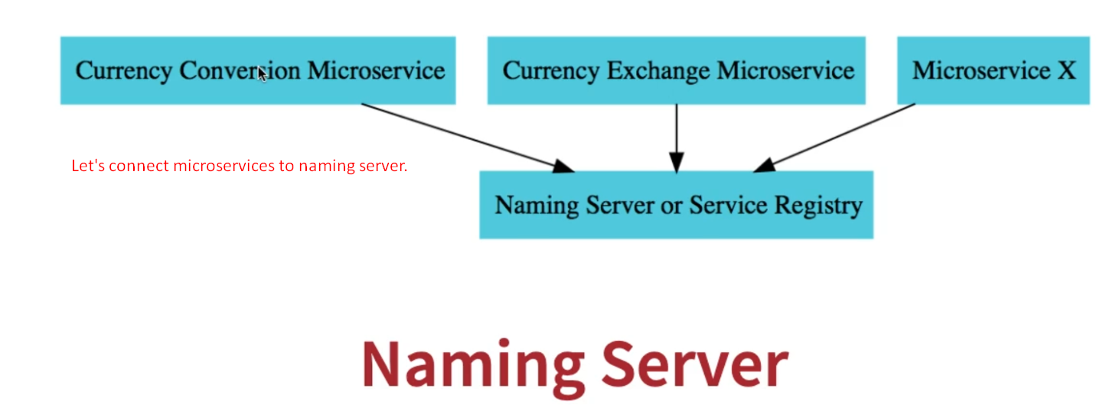
2. 
3. Add this dependency to both Currency related microservices.
4. First run the “Naming Server” app then the currency microservices.  
   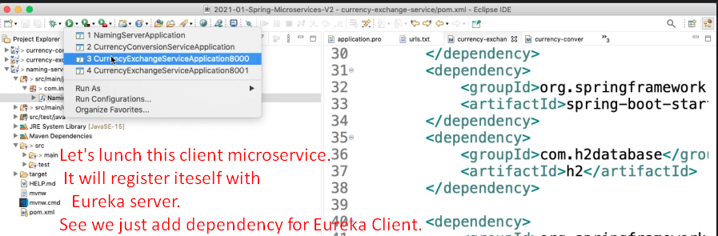
5. 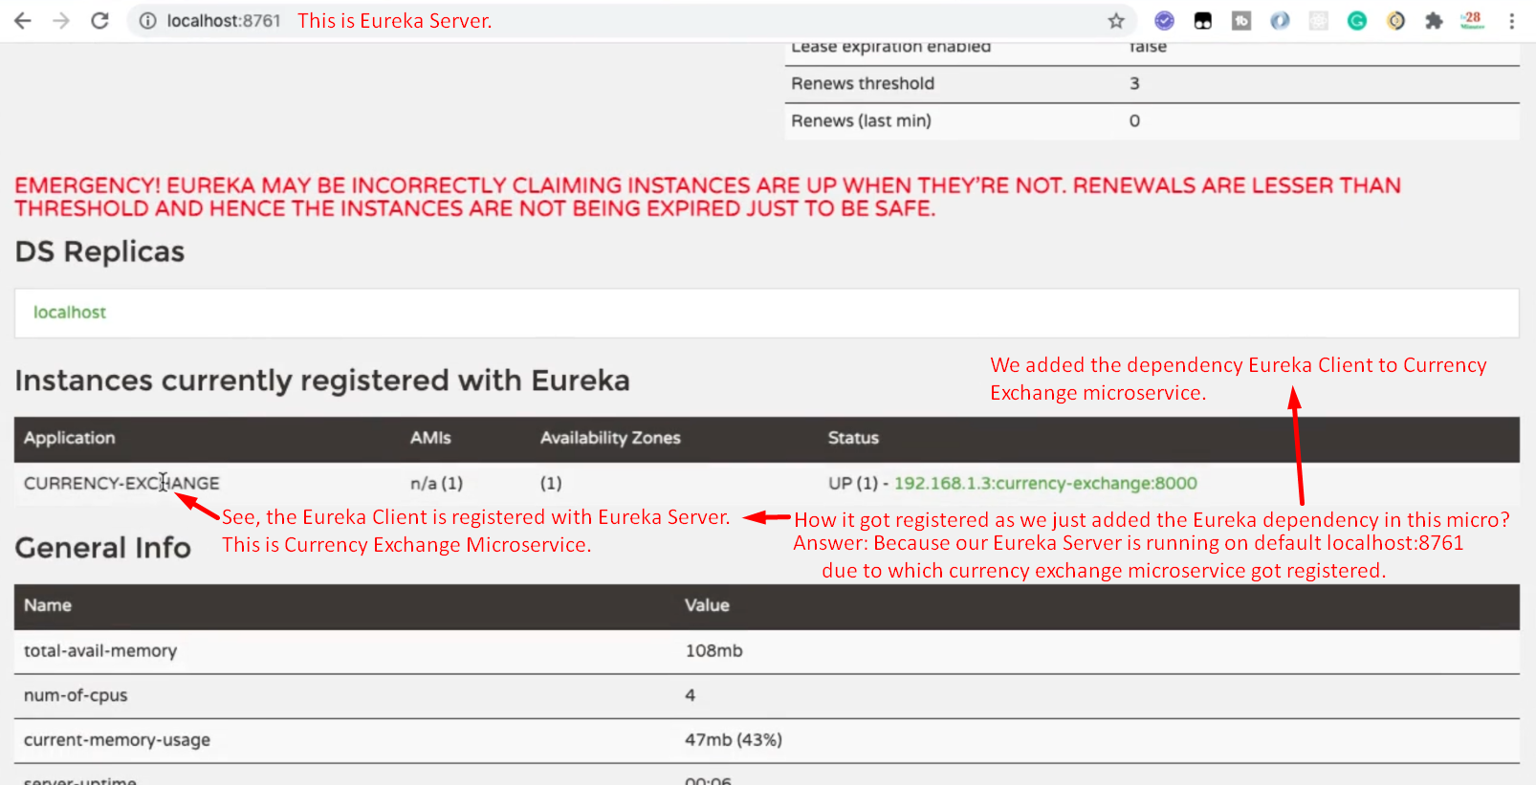

But we can configure the Eureka Server address in application.properties file overriding the default value. 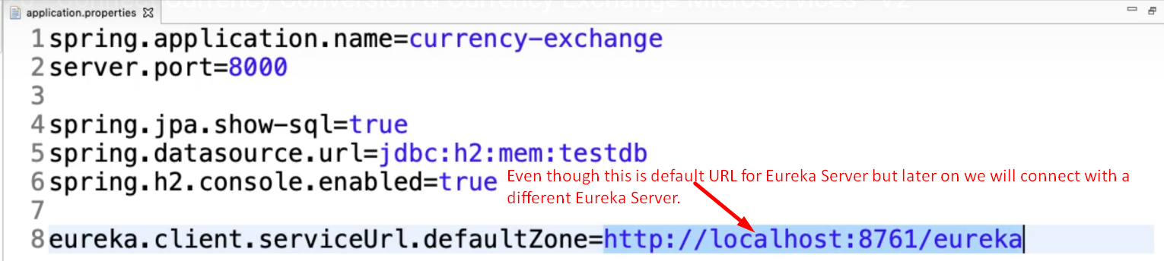

1. 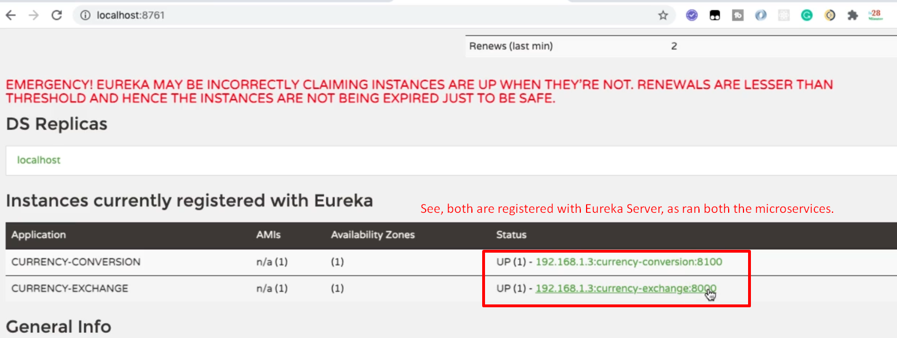
2. 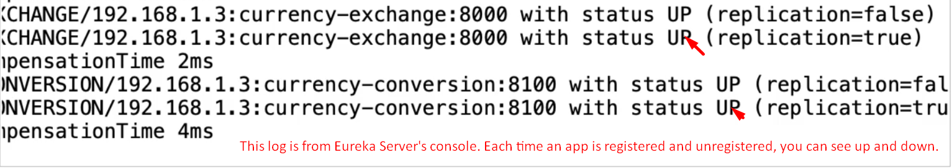
3. 